Centro Educacional Brasil Portugal
Teacher: Márcia Cristine | Subject: English | Class:__________
Name:_______________________________________________________
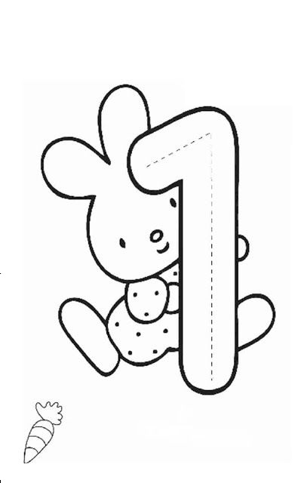
Let`s color!
(Vamos colorir!)

